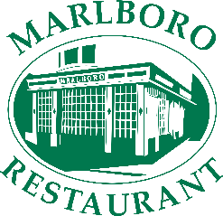

LARGE GROUP RESTAURANT BOOKINGS FORM

Please fill out this order form in advance, upon and email the order form to Lauren.Tomlin@marlbororestaurant.co.uk
You can also phone us on 01305 785700 to discuss any further details.
Please use our Restaurant menu as reference prior to booking www.marlbororestaurant.co.uk/restaurant-menu
Name
Email
Phone Number
Address

Booking Date
Booking Time
Group Size
Standard Menu or Bottomless Brunch Menu

Additional Notes / Information (If Required)

Please note that due to the nature of our operation, we cannot guarantee an allergen free dish. For more details, please contact us ahead of ordering.

